GVault QDMS Post Go-Live Survey

The analysis include exploratoray data analysis, correlation analysis, tests of association, a multinomial logistic regression model and an ordinal logistic regression model.

Let’s begin by loading RCurl package to retrieve dataset from Github repositoory.

Load the data

#Raw dataset  
df1<-read.csv("Gvault_survey_raw.csv",header=T)

### EXPLORATORY DATA ANALYSIS

Load package plotrix for ploting 3D pie charts

require("plotrix")

## Loading required package: plotrix

Lets explore the frequency of single choice questions.

1. How frequently do you use GVault QDMS?

mytable=table(df1$freq_use)  
mytable

##   
## At least once a month At least once a week Daily   
## 51 144 245   
## Less than once a month   
## 35

barplot(mytable,ylab = "responses",col = "light green",  
 ,srt=45,las=2,yaxt='n',cex.names = 0.65,cex.lab=0.65)

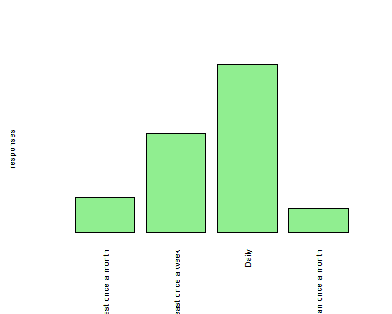

1. What is your role within GVault QDMS?

mytable=table(df1$role)  
barplot(mytable,ylab = "responses",col = "light green",  
 srt=45,las=2,yaxt='n',cex.names = 0.65,cex.lab=0.65)

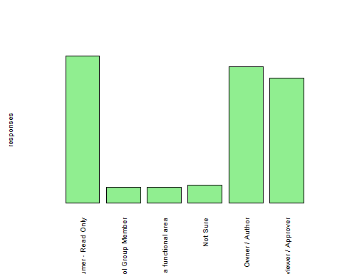

1. How would you describe the effectiveness of training you received?

table(df1$training_effectiveness)

##   
## Effective I did not take training Not effective enough   
## 291 29 72   
## Very effective   
## 83

barplot(table(df1$training_effectiveness),ylab = "responses",col = "light green",srt=45,las=2,yaxt='n',cex.names = 0.65,cex.lab=0.65)

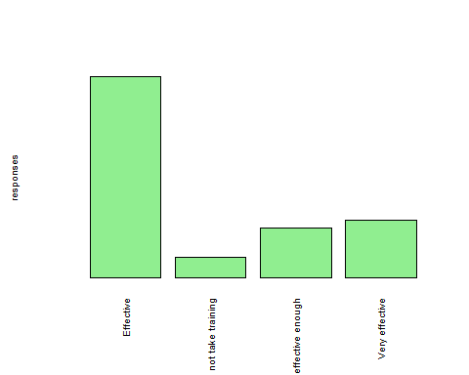

1. Are you able to complete work in the system without ‘help’ or ‘intervention’?

require(plotrix)  
mytable=table(df1$complete_without_help)  
lbls <- paste(names(mytable), "\n", mytable, sep="")  
pie3D(mytable, labels = lbls,explode=0.3)

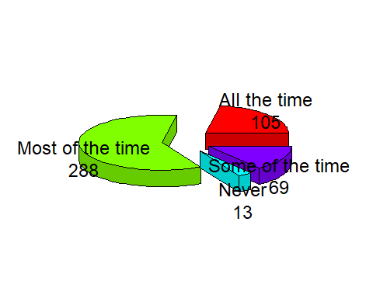

1. Do you find it easy to search for and access documents in GVault QDMS?

mytable=table(df1$easy_access_documents)  
lbls <- paste(names(mytable), "\n", mytable, sep="")  
pie3D(mytable, labels = lbls,explode=0.3)

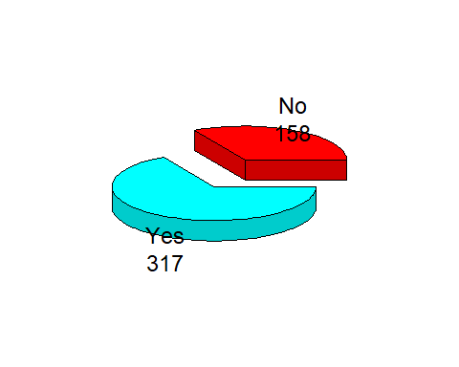

1. How satisfied are you with the overall experience of GVault QDMS?

mytable=table(df1$satisfaction)  
lbls <- paste(names(mytable), "\n", mytable, sep="")  
pie3D(mytable, labels = lbls,explode=0.3)

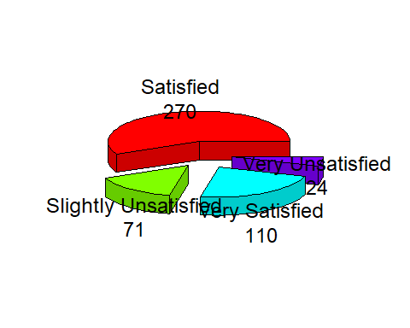

1. How would you describe your efficiency with GVault as compared to GDocs?

table(df1$Gvault_efficiency)

##   
## Decreased Increased   
## 18 75 270   
## No noticeable difference   
## 112

barplot(table(df1$Gvault_efficiency),ylab = "responses",col = "light green",srt=45,las=2,yaxt='n',cex.names = 0.65,cex.lab=0.65)

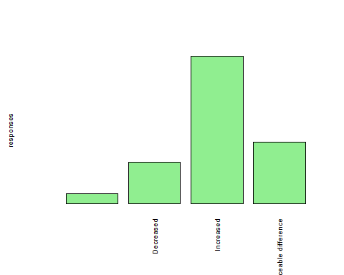

1. Do you find GVault has improved features and functionality compared to GDocs?

table(df1$Gvault_improved)

##   
## No Yes   
## 28 81 366

barplot(table(df1$Gvault_improved),ylab="responses",  
 col="light green",las=2, yaxt='n',cex.names = 0.65,cex.lab=0.65)

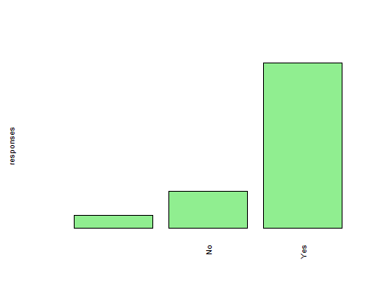

### Demographics analysis

1. What is your functional area?

table(df1$functional_area)

##   
##   
## 6   
## Commercial   
## 12   
## Facilities and Operations   
## 13   
## Finance   
## 1   
## Information Technology (IT)   
## 70   
## Other (please specify)   
## 37   
## Pharmaceutical Development and Manufacturing (PDM)   
## 217   
## Research and Development (R&D)   
## 119

barplot(table(df1$functional_area),ylab = "responses",col = "light green",srt=45,las=2,yaxt='n',cex.names = 0.65,cex.lab=0.65)

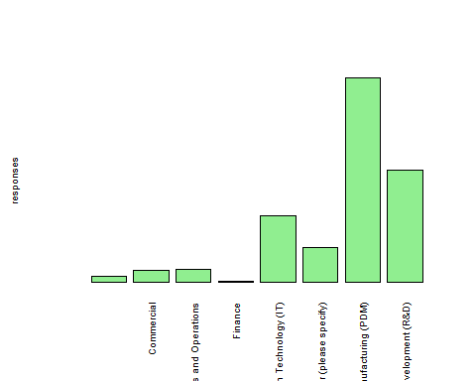

1. What is your office location?

table(df1$office_location)

##   
## Alberta Cambridge   
## 6 39 15   
## Cork/Dublin Foster City Oceanside   
## 25 244 22   
## Other (please specify) San Dimas/La Verne Seattle   
## 70 34 11   
## Stockley Park   
## 9

barplot(table(df1$office_location),ylab = "responses",col = "light green",srt=45,las=2,yaxt='n',cex.names = 0.65,cex.lab=0.65)

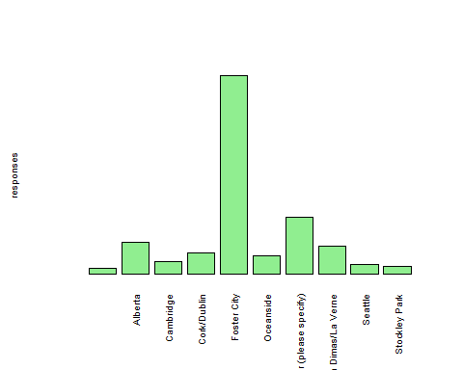

1. What is your Job Level?

table(df1$job_level)

##   
## Director Executive Leadership   
## 6 72 4   
## Individual Contributor Manager / Group Leader Other (please specify)   
## 208 133 52

barplot(table(df1$job_level),ylab = "responses",col = "light green",  
 srt=45,las=2,yaxt='n',cex.names = 0.65,cex.lab=0.65)

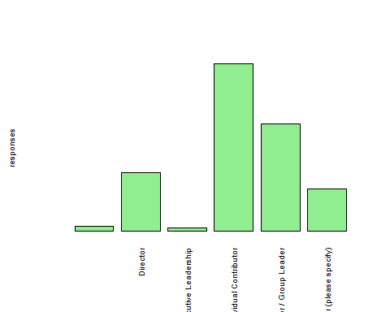

1. How long have you worked at Gilead?

table(df1$time_worked_Glead)

##   
## >7 Years 1 to 2 years 3-4 years   
## 6 123 73 128   
## 5-7 years Less than a year   
## 84 61

barplot(table(df1$time_worked_Glead),ylab = "responses",col = "light green",srt=45,las=2,yaxt='n',cex.names = 0.65,cex.lab=0.65)

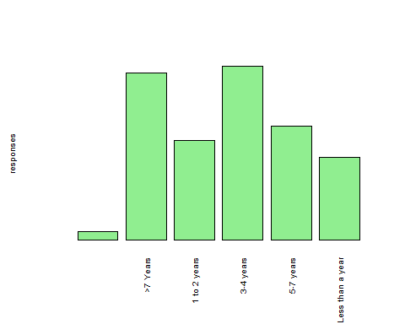

#### Correlation analysis: Spearman’s Rank test

The variables involved are made up of ordered data and thus Spearman’s rank orrelation test would be the best correlation type to use.

require("pspearman")

## Loading required package: pspearman

#### Decision rule: If the p-value < 0.05 then the null hypothesis is rejected, else it is upheld.

#### Correlation test between frequency of use and satisfaction

Null hypothesis: There was no statistically significant relationship between median frequency of use and the median satisfaction.

Alternative hypothesis: There was statistically significant relationship between median frequency of use and the median satisfaction.

# Spearman test   
library(pspearman)  
spearman.test(df1$satisfaction, df1$freq_use, alternative = c("two.sided", "less", "greater"), approximation = c("exact", "AS89", "t-distribution"))

## Warning in spearman.test(df1$satisfaction, df1$freq_use, alternative =  
## c("two.sided", : Cannot compute exact p-values with ties

##   
## Spearman's rank correlation rho  
##   
## data: df1$satisfaction and df1$freq_use  
## S = 18549741, p-value = 0.4022  
## alternative hypothesis: true rho is not equal to 0  
## sample estimates:  
## rho   
## -0.03850882

#### Correlation test between satisfaction and effectiveness of training

Null hypothesis: There was no statistically significant relationship between median training effectiveness and the median satisfaction.

Alternative hypothesis: There was statistically significant relationship between median training effectiveness and the median satisfaction.

library(pspearman)  
spearman.test(df1$satisfaction, df1$training_effectiveness, alternative = c("two.sided", "less", "greater"), approximation = c("exact", "AS89", "t-distribution"))

## Warning in spearman.test(df1$satisfaction, df1$training_effectiveness,  
## alternative = c("two.sided", : Cannot compute exact p-values with ties

##   
## Spearman's rank correlation rho  
##   
## data: df1$satisfaction and df1$training_effectiveness  
## S = 12718507, p-value = 1.946e-10  
## alternative hypothesis: true rho is not equal to 0  
## sample estimates:  
## rho   
## 0.2879533

#### Correlation test between satisfaction and the extend by which users complete work in the system without help/intervention

##### Null hypothesis:

There was no statistically significant relationship between median of the rank in completing workwithout help and the median rank in satisfaction.

##### Alternative hypothesis:

There was statistically significant relationship between median of the rank in completing workwithout help and the median rank in satisfaction.

library(pspearman)  
spearman.test(df1$satisfaction, df1$complete_without_help, alternative = c("two.sided", "less", "greater"), approximation = c("exact", "AS89", "t-distribution"))

## Warning in spearman.test(df1$satisfaction, df1$complete_without_help,  
## alternative = c("two.sided", : Cannot compute exact p-values with ties

##   
## Spearman's rank correlation rho  
##   
## data: df1$satisfaction and df1$complete_without_help  
## S = 19443695, p-value = 0.05378  
## alternative hypothesis: true rho is not equal to 0  
## sample estimates:  
## rho   
## -0.08855691

#### Test of Association: Chi-square test of independence

The variables that were tested for association with the satisfaction variable had nominal data, thus Chi-square test of independence was the best test to use.

#### Decision rule: If the p-value < 0.05 then the null hypothesis is rejected, else it is upheld.

#### Test of association between satisfction and the role of a user in Gvault.

##### Null hypothesis:

There was no association between ease of a user to search for and access documents in Gvault and satisfaction of the user with Gvault.

##### Alternative hypothesis:

There was association between role of a user in Gvault and satisfaction of the user with Gvault.

chisq.test(df1$satisfaction,df1$role)

## Warning in chisq.test(df1$satisfaction, df1$role): Chi-squared approximation may  
## be incorrect

##   
## Pearson's Chi-squared test  
##   
## data: df1$satisfaction and df1$role  
## X-squared = 20.391, df = 15, p-value = 0.1574

#### Test of association between satisfction and the ease of a user to search and access documents in Gvault.

##### Null hypothesis:

There was no association between satisfction and the ease of a user to search and access documents in Gvault.

##### Alternative hypothesis:

There was association between satisfction and the ease of a user to search and access documents in Gvault.

chisq.test(df1$satisfaction,df1$easy_access_documents)

##   
## Pearson's Chi-squared test  
##   
## data: df1$satisfaction and df1$easy_access_documents  
## X-squared = 148.79, df = 3, p-value < 2.2e-16

#### Findings and Summary of the correlation and association tests

#### Finding 1

There was a significant relationship between effectiveness of training and satisfaction of users, wherease frequency of use and the extent of completing work without help were not related to satisfaction. This is because their p-values were greater than 0.05 while that of effective training was less than 0.05

#### Finding 2

The role of a user was in any way related to satisfaction whereas the ease of access to documents in Gvault has a high association with satisfaction. This is also attributed to the szize of their p-values.

### Multinomial logistic regression

This model is selected when the response variable is categorical with more than one class/level. In our case the satisfaction variable is categorical with 4 classes. Thus we fit a multinomial logistic regssion model.

Load required packages first.

require(foreign)

## Loading required package: foreign

require(nnet)

## Loading required package: nnet

require(ggplot2)

## Loading required package: ggplot2

require(reshape2)

## Loading required package: reshape2

First, we need to choose the level of our outcome that we wish to use as our baseline and specify this in the relevel function. Then, we run our model using multinom. The multinom package does not include p-value calculation for the regression coefficients, so we calculate p-values using Wald tests (here z-tests).

#Render the variables available in R environment  
attach(df1)  
  
#Specify the reference level in satisfiaction variable  
df1$satisfaction2 <- relevel(df1$satisfaction, ref="Very Unsatisfied")  
  
#Fit the model to the data  
test <- multinom(satisfaction2 ~ freq_use + role + training_instructor_led + training_web_based + training_read + no_training + training_effectiveness + support_Gnet + support_inapplication + support_ref_doc + support_SOP + support_contacted + support_IT + complete_without_help + easy_access_documents + easy_access_documents + Gvault_efficiency + Gvault_improved, data =df1)

## # weights: 128 (93 variable)  
## initial value 658.489822   
## iter 10 value 337.842690  
## iter 20 value 309.507455  
## iter 30 value 301.419694  
## iter 40 value 299.085269  
## iter 50 value 298.178512  
## iter 60 value 297.619233  
## iter 70 value 297.205100  
## iter 80 value 297.104932  
## iter 90 value 297.086290  
## iter 100 value 297.085792  
## final value 297.085792   
## stopped after 100 iterations

#Explore the model  
summary(test)

## Call:  
## multinom(formula = satisfaction2 ~ freq_use + role + training_instructor_led +   
## training_web_based + training_read + no_training + training_effectiveness +   
## support_Gnet + support_inapplication + support_ref_doc +   
## support_SOP + support_contacted + support_IT + complete_without_help +   
## easy_access_documents + easy_access_documents + Gvault_efficiency +   
## Gvault_improved, data = df1)  
##   
## Coefficients:  
## (Intercept) freq_useAt least once a week freq_useDaily  
## Satisfied 29.892912 -1.0464241 -1.6092965  
## Slightly Unsatisfied 27.152910 0.6649767 -0.6807785  
## Very Satisfied 2.992459 -1.5161025 -2.6200160  
## freq_useLess than once a month  
## Satisfied -1.1521884  
## Slightly Unsatisfied -0.1639594  
## Very Satisfied -1.0590008  
## roleDocument Control Group Member  
## Satisfied 19.70286  
## Slightly Unsatisfied 19.68529  
## Very Satisfied 20.57107  
## roleDocument Steward for a functional area roleNot Sure  
## Satisfied 11.45632 1.9330019  
## Slightly Unsatisfied 11.71621 0.4735276  
## Very Satisfied 12.76773 2.5837512  
## roleOwner / Author roleReviewer / Approver  
## Satisfied -0.9555552 -0.2080407  
## Slightly Unsatisfied -0.5883840 0.2050369  
## Very Satisfied -0.3767514 0.4511106  
## training_instructor_ledInstructor Led  
## Satisfied 0.2892213  
## Slightly Unsatisfied 0.7384314  
## Very Satisfied 0.6642465  
## training_web_basedWeb/Computer Based  
## Satisfied 0.08344278  
## Slightly Unsatisfied 0.36701806  
## Very Satisfied -0.08024619  
## training_readRead & Understood of Procedural Document(s)  
## Satisfied 0.5999787  
## Slightly Unsatisfied 0.7867855  
## Very Satisfied 1.2945777  
## no_trainingI did not take training  
## Satisfied 12.82061  
## Slightly Unsatisfied 13.32519  
## Very Satisfied -12.06418  
## training_effectivenessI did not take training  
## Satisfied -14.95071  
## Slightly Unsatisfied -15.10639  
## Very Satisfied 10.66035  
## training_effectivenessNot effective enough  
## Satisfied -0.9414354  
## Slightly Unsatisfied -0.0181524  
## Very Satisfied -0.3874174  
## training_effectivenessVery effective support_GnetGNet  
## Satisfied -1.4728986 0.7208296  
## Slightly Unsatisfied -1.5851626 0.2303046  
## Very Satisfied 0.1450811 0.9290451  
## support_inapplicationIn-Application (GVault)  
## Satisfied -0.6718196  
## Slightly Unsatisfied -0.4475563  
## Very Satisfied 0.1815383  
## support_ref_docReference Document (User Manual, Reference Guide, Training Material, etc)  
## Satisfied 0.11819454  
## Slightly Unsatisfied -0.07655518  
## Very Satisfied 0.96082149  
## support_SOPSOPs and Work Instructions  
## Satisfied -0.4793529  
## Slightly Unsatisfied -0.3922151  
## Very Satisfied -0.3325414  
## support_contactedContacted my Document Control or Training Group  
## Satisfied 1.874356  
## Slightly Unsatisfied 1.462219  
## Very Satisfied 1.693343  
## support_ITIT Support / SPARC  
## Satisfied -0.2496686  
## Slightly Unsatisfied -0.9914639  
## Very Satisfied -0.6146530  
## complete_without_helpMost of the time  
## Satisfied 1.2276585  
## Slightly Unsatisfied 1.0496848  
## Very Satisfied -0.1389349  
## complete_without_helpNever  
## Satisfied -3.018073  
## Slightly Unsatisfied -1.500685  
## Very Satisfied -32.441409  
## complete_without_helpSome of the time  
## Satisfied -1.1918894  
## Slightly Unsatisfied -0.2484145  
## Very Satisfied -3.4083083  
## easy_access_documentsYes Gvault_efficiencyDecreased  
## Satisfied 2.03196332 1.074572  
## Slightly Unsatisfied 0.02590678 2.951201  
## Very Satisfied 3.66650136 -6.852901  
## Gvault_efficiencyIncreased  
## Satisfied 3.445498  
## Slightly Unsatisfied 3.858661  
## Very Satisfied 27.117674  
## Gvault_efficiencyNo noticeable difference  
## Satisfied 3.483958  
## Slightly Unsatisfied 4.154464  
## Very Satisfied 26.211835  
## Gvault_improvedNo Gvault_improvedYes  
## Satisfied -31.60827 -28.98872  
## Slightly Unsatisfied -30.64266 -30.12729  
## Very Satisfied -31.49416 -28.38447  
##   
## Std. Errors:  
## (Intercept) freq_useAt least once a week freq_useDaily  
## Satisfied 2.284162 1.498719 1.532615  
## Slightly Unsatisfied 2.286368 1.510786 1.539384  
## Very Satisfied 1.205757 1.576585 1.610055  
## freq_useLess than once a month  
## Satisfied 1.670606  
## Slightly Unsatisfied 1.729525  
## Very Satisfied 1.830170  
## roleDocument Control Group Member  
## Satisfied 0.7085796  
## Slightly Unsatisfied 1.3096088  
## Very Satisfied 0.8333562  
## roleDocument Steward for a functional area roleNot Sure  
## Satisfied 0.5229938 1.800196  
## Slightly Unsatisfied 0.9094240 2.056229  
## Very Satisfied 0.6437218 2.036011  
## roleOwner / Author roleReviewer / Approver  
## Satisfied 0.9168420 0.9595108  
## Slightly Unsatisfied 0.8688543 0.9171351  
## Very Satisfied 1.0136123 1.0472881  
## training_instructor_ledInstructor Led  
## Satisfied 0.7540379  
## Slightly Unsatisfied 0.7134694  
## Very Satisfied 0.8394642  
## training_web_basedWeb/Computer Based  
## Satisfied 0.7445177  
## Slightly Unsatisfied 0.7030741  
## Very Satisfied 0.8086001  
## training_readRead & Understood of Procedural Document(s)  
## Satisfied 0.6990999  
## Slightly Unsatisfied 0.6611094  
## Very Satisfied 0.7807743  
## no_trainingI did not take training  
## Satisfied 1.2780961  
## Slightly Unsatisfied 1.2856852  
## Very Satisfied 0.8086589  
## training_effectivenessI did not take training  
## Satisfied 1.2837610  
## Slightly Unsatisfied 1.3219892  
## Very Satisfied 0.8086589  
## training_effectivenessNot effective enough  
## Satisfied 0.7688629  
## Slightly Unsatisfied 0.7046490  
## Very Satisfied 0.9881175  
## training_effectivenessVery effective support_GnetGNet  
## Satisfied 1.548623 0.7834088  
## Slightly Unsatisfied 1.636743 0.7691871  
## Very Satisfied 1.569124 0.8379164  
## support_inapplicationIn-Application (GVault)  
## Satisfied 0.9089550  
## Slightly Unsatisfied 0.8632206  
## Very Satisfied 0.9511169  
## support_ref_docReference Document (User Manual, Reference Guide, Training Material, etc)  
## Satisfied 0.7841996  
## Slightly Unsatisfied 0.7653153  
## Very Satisfied 0.8401476  
## support_SOPSOPs and Work Instructions  
## Satisfied 0.7380242  
## Slightly Unsatisfied 0.6987684  
## Very Satisfied 0.7936987  
## support_contactedContacted my Document Control or Training Group  
## Satisfied 0.8070249  
## Slightly Unsatisfied 0.7660060  
## Very Satisfied 0.8642395  
## support_ITIT Support / SPARC  
## Satisfied 1.119987  
## Slightly Unsatisfied 1.118713  
## Very Satisfied 1.204909  
## complete_without_helpMost of the time  
## Satisfied 1.111132  
## Slightly Unsatisfied 1.084986  
## Very Satisfied 1.153693  
## complete_without_helpNever  
## Satisfied 1.613816e+00  
## Slightly Unsatisfied 1.558665e+00  
## Very Satisfied 1.445581e-11  
## complete_without_helpSome of the time  
## Satisfied 1.191318  
## Slightly Unsatisfied 1.117069  
## Very Satisfied 1.421814  
## easy_access_documentsYes Gvault_efficiencyDecreased  
## Satisfied 0.8232154 1.940619e+00  
## Slightly Unsatisfied 0.8389209 2.101728e+00  
## Very Satisfied 1.0033443 1.135371e-12  
## Gvault_efficiencyIncreased  
## Satisfied 2.0890273  
## Slightly Unsatisfied 2.2479712  
## Very Satisfied 0.9066254  
## Gvault_efficiencyNo noticeable difference  
## Satisfied 2.1016647  
## Slightly Unsatisfied 2.2471119  
## Very Satisfied 0.8108819  
## Gvault_improvedNo Gvault_improvedYes  
## Satisfied 1.077606 0.915121  
## Slightly Unsatisfied 1.179640 1.045968  
## Very Satisfied 1.610290 1.164006  
##   
## Residual Deviance: 594.1716   
## AIC: 780.1716

#### P-values to show which predictors were significant in explaining variation in the model

z <- summary(test)$coefficients/summary(test)$standard.errors  
# 2-tailed z test  
p <- (1 - pnorm(abs(z), 0, 1)) * 2  
p

## (Intercept) freq_useAt least once a week freq_useDaily  
## Satisfied 0.00000000 0.4850445 0.2937029  
## Slightly Unsatisfied 0.00000000 0.6598265 0.6583150  
## Very Satisfied 0.01307175 0.3362318 0.1036769  
## freq_useLess than once a month  
## Satisfied 0.4903936  
## Slightly Unsatisfied 0.9244735  
## Very Satisfied 0.5628354  
## roleDocument Control Group Member  
## Satisfied 0  
## Slightly Unsatisfied 0  
## Very Satisfied 0  
## roleDocument Steward for a functional area roleNot Sure  
## Satisfied 0 0.2829245  
## Slightly Unsatisfied 0 0.8178670  
## Very Satisfied 0 0.2044318  
## roleOwner / Author roleReviewer / Approver  
## Satisfied 0.2973076 0.8283490  
## Slightly Unsatisfied 0.4982821 0.8230979  
## Very Satisfied 0.7101223 0.6666563  
## training_instructor_ledInstructor Led  
## Satisfied 0.7013021  
## Slightly Unsatisfied 0.3006751  
## Very Satisfied 0.4287839  
## training_web_basedWeb/Computer Based  
## Satisfied 0.9107629  
## Slightly Unsatisfied 0.6016571  
## Very Satisfied 0.9209470  
## training_readRead & Understood of Procedural Document(s)  
## Satisfied 0.39077322  
## Slightly Unsatisfied 0.23400755  
## Very Satisfied 0.09730353  
## no_trainingI did not take training  
## Satisfied 0  
## Slightly Unsatisfied 0  
## Very Satisfied 0  
## training_effectivenessI did not take training  
## Satisfied 0  
## Slightly Unsatisfied 0  
## Very Satisfied 0  
## training_effectivenessNot effective enough  
## Satisfied 0.2207819  
## Slightly Unsatisfied 0.9794480  
## Very Satisfied 0.6950019  
## training_effectivenessVery effective support_GnetGNet  
## Satisfied 0.3415527 0.3575104  
## Slightly Unsatisfied 0.3328017 0.7646250  
## Very Satisfied 0.9263326 0.2675353  
## support_inapplicationIn-Application (GVault)  
## Satisfied 0.4598390  
## Slightly Unsatisfied 0.6041286  
## Very Satisfied 0.8486286  
## support_ref_docReference Document (User Manual, Reference Guide, Training Material, etc)  
## Satisfied 0.8801966  
## Slightly Unsatisfied 0.9203198  
## Very Satisfied 0.2527754  
## support_SOPSOPs and Work Instructions  
## Satisfied 0.5160098  
## Slightly Unsatisfied 0.5745966  
## Very Satisfied 0.6752330  
## support_contactedContacted my Document Control or Training Group  
## Satisfied 0.02020329  
## Slightly Unsatisfied 0.05627660  
## Very Satisfied 0.05007249  
## support_ITIT Support / SPARC  
## Satisfied 0.8235970  
## Slightly Unsatisfied 0.3754806  
## Very Satisfied 0.6099646  
## complete_without_helpMost of the time  
## Satisfied 0.2692150  
## Slightly Unsatisfied 0.3333123  
## Very Satisfied 0.9041455  
## complete_without_helpNever  
## Satisfied 0.06146341  
## Slightly Unsatisfied 0.33564727  
## Very Satisfied 0.00000000  
## complete_without_helpSome of the time  
## Satisfied 0.31707837  
## Slightly Unsatisfied 0.82401754  
## Very Satisfied 0.01652291  
## easy_access_documentsYes Gvault_efficiencyDecreased  
## Satisfied 0.0135746959 0.5797659  
## Slightly Unsatisfied 0.9753643855 0.1602658  
## Very Satisfied 0.0002579043 0.0000000  
## Gvault_efficiencyIncreased  
## Satisfied 0.09907975  
## Slightly Unsatisfied 0.08606904  
## Very Satisfied 0.00000000  
## Gvault_efficiencyNo noticeable difference  
## Satisfied 0.09737530  
## Slightly Unsatisfied 0.06448645  
## Very Satisfied 0.00000000  
## Gvault_improvedNo Gvault_improvedYes  
## Satisfied 0 0  
## Slightly Unsatisfied 0 0  
## Very Satisfied 0 0

#### Finding from the p-values

The variable Gvault_improved was significant in predicting the odds of a user being very satisfied. Document stewart for a functional area and Document control group member were the roles that influence the odds of satisfaction. Most predictor variables had an effect on the odds of a user being very satisfied vs being very unsatisfied.

#### ODDS Ratios

Extract the coefficients from the model and exponentiate to get the ODD ratios

exp(coef(test))

## (Intercept) freq_useAt least once a week freq_useDaily  
## Satisfied 9.601223e+12 0.3511913 0.2000283  
## Slightly Unsatisfied 6.199533e+11 1.9444452 0.5062228  
## Very Satisfied 1.993463e+01 0.2195660 0.0728017  
## freq_useLess than once a month  
## Satisfied 0.3159446  
## Slightly Unsatisfied 0.8487765  
## Very Satisfied 0.3468022  
## roleDocument Control Group Member  
## Satisfied 360449230  
## Slightly Unsatisfied 354170382  
## Very Satisfied 858820739  
## roleDocument Steward for a functional area roleNot Sure  
## Satisfied 94496.95 6.910223  
## Slightly Unsatisfied 122542.28 1.605648  
## Very Satisfied 350715.56 13.246736  
## roleOwner / Author roleReviewer / Approver  
## Satisfied 0.3845986 0.812174  
## Slightly Unsatisfied 0.5552238 1.227570  
## Very Satisfied 0.6860866 1.570055  
## training_instructor_ledInstructor Led  
## Satisfied 1.335387  
## Slightly Unsatisfied 2.092650  
## Very Satisfied 1.943026  
## training_web_basedWeb/Computer Based  
## Satisfied 1.0870230  
## Slightly Unsatisfied 1.4434240  
## Very Satisfied 0.9228891  
## training_readRead & Understood of Procedural Document(s)  
## Satisfied 1.822080  
## Slightly Unsatisfied 2.196325  
## Very Satisfied 3.649455  
## no_trainingI did not take training  
## Satisfied 3.697612e+05  
## Slightly Unsatisfied 6.124279e+05  
## Very Satisfied 5.762262e-06  
## training_effectivenessI did not take training  
## Satisfied 3.213576e-07  
## Slightly Unsatisfied 2.750284e-07  
## Very Satisfied 4.263146e+04  
## training_effectivenessNot effective enough  
## Satisfied 0.3900675  
## Slightly Unsatisfied 0.9820114  
## Very Satisfied 0.6788077  
## training_effectivenessVery effective support_GnetGNet  
## Satisfied 0.2292600 2.056138  
## Slightly Unsatisfied 0.2049145 1.258983  
## Very Satisfied 1.1561334 2.532090  
## support_inapplicationIn-Application (GVault)  
## Satisfied 0.5107783  
## Slightly Unsatisfied 0.6391882  
## Very Satisfied 1.1990605  
## support_ref_docReference Document (User Manual, Reference Guide, Training Material, etc)  
## Satisfied 1.1254630  
## Slightly Unsatisfied 0.9263018  
## Very Satisfied 2.6138428  
## support_SOPSOPs and Work Instructions  
## Satisfied 0.6191839  
## Slightly Unsatisfied 0.6755588  
## Very Satisfied 0.7170990  
## support_contactedContacted my Document Control or Training Group  
## Satisfied 6.516624  
## Slightly Unsatisfied 4.315527  
## Very Satisfied 5.437626  
## support_ITIT Support / SPARC  
## Satisfied 0.7790589  
## Slightly Unsatisfied 0.3710331  
## Very Satisfied 0.5408285  
## complete_without_helpMost of the time  
## Satisfied 3.4132279  
## Slightly Unsatisfied 2.8567506  
## Very Satisfied 0.8702847  
## complete_without_helpNever  
## Satisfied 4.889533e-02  
## Slightly Unsatisfied 2.229774e-01  
## Very Satisfied 8.144701e-15  
## complete_without_helpSome of the time  
## Satisfied 0.30364700  
## Slightly Unsatisfied 0.78003653  
## Very Satisfied 0.03309714  
## easy_access_documentsYes Gvault_efficiencyDecreased  
## Satisfied 7.629050 2.928740375  
## Slightly Unsatisfied 1.026245 19.128910192  
## Very Satisfied 39.114817 0.001056387  
## Gvault_efficiencyIncreased  
## Satisfied 3.135891e+01  
## Slightly Unsatisfied 4.740185e+01  
## Very Satisfied 5.984891e+11  
## Gvault_efficiencyNo noticeable difference  
## Satisfied 3.258845e+01  
## Slightly Unsatisfied 6.371783e+01  
## Very Satisfied 2.419109e+11  
## Gvault_improvedNo Gvault_improvedYes  
## Satisfied 1.873708e-14 2.572514e-13  
## Slightly Unsatisfied 4.921121e-14 8.239173e-14  
## Very Satisfied 2.100194e-14 4.707385e-13

#### Interpretation of the odds ratios

For instance the ease of access to documents increased the odds of satisfaction by 39.11 times.

#### Probabilities of satisfaction

You can also use predicted probabilities to help you understand the model. You can calculate predicted probabilities for each of our outcome levels using the fitted function. We can start by generating the predicted probabilities for the observations in our dataset and viewing the first few rows

head(pp <- fitted(test))

## Very Unsatisfied Satisfied Slightly Unsatisfied Very Satisfied  
## 1 3.941143e-04 0.7344955 0.014087374 0.25102297  
## 2 1.910445e-03 0.7233229 0.033338361 0.24142829  
## 3 1.036560e-03 0.5164083 0.017960261 0.46459488  
## 4 6.272947e-04 0.8829404 0.010387354 0.10604498  
## 5 2.394410e-15 0.8125645 0.105980105 0.08145536  
## 6 8.415195e-05 0.6809652 0.008372793 0.31057785

#### Interpretation at a glance

#### Summary

### Ordinal Logistic Regression (OLR)

This model was selected also because the response variable can be measure on an ordinal scale. We begin by Loading the packages.

require(foreign)  
require(ggplot2)  
require(MASS)

## Loading required package: MASS

require(Hmisc)

## Loading required package: Hmisc

## Loading required package: lattice

## Loading required package: survival

## Loading required package: Formula

##   
## Attaching package: 'Hmisc'

## The following object is masked from 'package:pspearman':  
##   
## spearman.test

## The following objects are masked from 'package:base':  
##   
## format.pval, units

require(reshape2)

For building this model, we will be using the polr command to estimate an ordered logistic regression. Then, we’ll specify Hess=TRUE to let the model output show the observed information matrix from optimization which is used to get standard errors.

#### Fit the Ordinal logistic regression model

m<-polr(df1$satisfaction ~ df1$freq_use + df1$role  
 +df1$training_instructor_led + df1$training_web_based  
 + df1$training_read+ df1$no_training+df1$training_effectiveness  
 + df1$support_Gnet + df1$support_inapplication  
 +df1$support_ref_doc + df1$support_SOP + df1$support_contacted  
 +df1$support_IT + df1$complete_without_help  
 +df1$easy_access_documents + df1$Gvault_efficiency  
 +df1$Gvault_improved,data=df1,Hess=TRUE)  
summary(m)

## Call:  
## polr(formula = df1$satisfaction ~ df1$freq_use + df1$role + df1$training_instructor_led +   
## df1$training_web_based + df1$training_read + df1$no_training +   
## df1$training_effectiveness + df1$support_Gnet + df1$support_inapplication +   
## df1$support_ref_doc + df1$support_SOP + df1$support_contacted +   
## df1$support_IT + df1$complete_without_help + df1$easy_access_documents +   
## df1$Gvault_efficiency + df1$Gvault_improved, data = df1,   
## Hess = TRUE)  
##   
## Coefficients:  
## Value  
## df1$freq_useAt least once a week -0.061256  
## df1$freq_useDaily -0.225149  
## df1$freq_useLess than once a month -0.298138  
## df1$roleDocument Control Group Member -0.035346  
## df1$roleDocument Steward for a functional area 0.839250  
## df1$roleNot Sure -0.710795  
## df1$roleOwner / Author 0.232541  
## df1$roleReviewer / Approver 0.149034  
## df1$training_instructor_ledInstructor Led -0.014088  
## df1$training_web_basedWeb/Computer Based -0.201767  
## df1$training_readRead & Understood of Procedural Document(s) 0.233305  
## df1$no_trainingI did not take training -2.164934  
## df1$training_effectivenessI did not take training 2.662338  
## df1$training_effectivenessNot effective enough 0.418935  
## df1$training_effectivenessVery effective 1.469944  
## df1$support_GnetGNet 0.007038  
## df1$support_inapplicationIn-Application (GVault) 0.672101  
## df1$support_ref_docReference Document (User Manual, Reference Guide, Training Material, etc) 0.349751  
## df1$support_SOPSOPs and Work Instructions 0.112311  
## df1$support_contactedContacted my Document Control or Training Group -0.224774  
## df1$support_ITIT Support / SPARC 0.062084  
## df1$complete_without_helpMost of the time -0.900815  
## df1$complete_without_helpNever 0.499156  
## df1$complete_without_helpSome of the time -0.261270  
## df1$easy_access_documentsYes -0.162641  
## df1$Gvault_efficiencyDecreased 0.925684  
## df1$Gvault_efficiencyIncreased 0.813776  
## df1$Gvault_efficiencyNo noticeable difference 0.107436  
## df1$Gvault_improvedNo 1.889843  
## df1$Gvault_improvedYes 0.539834  
## Std. Error  
## df1$freq_useAt least once a week 0.3640  
## df1$freq_useDaily 0.3642  
## df1$freq_useLess than once a month 0.5118  
## df1$roleDocument Control Group Member 0.5846  
## df1$roleDocument Steward for a functional area 0.5561  
## df1$roleNot Sure 0.6216  
## df1$roleOwner / Author 0.2884  
## df1$roleReviewer / Approver 0.2782  
## df1$training_instructor_ledInstructor Led 0.2450  
## df1$training_web_basedWeb/Computer Based 0.2269  
## df1$training_readRead & Understood of Procedural Document(s) 0.2339  
## df1$no_trainingI did not take training 1.3209  
## df1$training_effectivenessI did not take training 1.3396  
## df1$training_effectivenessNot effective enough 0.2972  
## df1$training_effectivenessVery effective 0.2688  
## df1$support_GnetGNet 0.2210  
## df1$support_inapplicationIn-Application (GVault) 0.2336  
## df1$support_ref_docReference Document (User Manual, Reference Guide, Training Material, etc) 0.2145  
## df1$support_SOPSOPs and Work Instructions 0.2152  
## df1$support_contactedContacted my Document Control or Training Group 0.2209  
## df1$support_ITIT Support / SPARC 0.3173  
## df1$complete_without_helpMost of the time 0.2542  
## df1$complete_without_helpNever 0.6184  
## df1$complete_without_helpSome of the time 0.3708  
## df1$easy_access_documentsYes 0.2574  
## df1$Gvault_efficiencyDecreased 0.8537  
## df1$Gvault_efficiencyIncreased 0.8234  
## df1$Gvault_efficiencyNo noticeable difference 0.8297  
## df1$Gvault_improvedNo 0.6701  
## df1$Gvault_improvedYes 0.6258  
## t value  
## df1$freq_useAt least once a week -0.16828  
## df1$freq_useDaily -0.61814  
## df1$freq_useLess than once a month -0.58252  
## df1$roleDocument Control Group Member -0.06046  
## df1$roleDocument Steward for a functional area 1.50921  
## df1$roleNot Sure -1.14345  
## df1$roleOwner / Author 0.80632  
## df1$roleReviewer / Approver 0.53578  
## df1$training_instructor_ledInstructor Led -0.05751  
## df1$training_web_basedWeb/Computer Based -0.88939  
## df1$training_readRead & Understood of Procedural Document(s) 0.99730  
## df1$no_trainingI did not take training -1.63898  
## df1$training_effectivenessI did not take training 1.98735  
## df1$training_effectivenessNot effective enough 1.40961  
## df1$training_effectivenessVery effective 5.46838  
## df1$support_GnetGNet 0.03184  
## df1$support_inapplicationIn-Application (GVault) 2.87713  
## df1$support_ref_docReference Document (User Manual, Reference Guide, Training Material, etc) 1.63043  
## df1$support_SOPSOPs and Work Instructions 0.52185  
## df1$support_contactedContacted my Document Control or Training Group -1.01772  
## df1$support_ITIT Support / SPARC 0.19564  
## df1$complete_without_helpMost of the time -3.54343  
## df1$complete_without_helpNever 0.80717  
## df1$complete_without_helpSome of the time -0.70457  
## df1$easy_access_documentsYes -0.63187  
## df1$Gvault_efficiencyDecreased 1.08428  
## df1$Gvault_efficiencyIncreased 0.98825  
## df1$Gvault_efficiencyNo noticeable difference 0.12949  
## df1$Gvault_improvedNo 2.82023  
## df1$Gvault_improvedYes 0.86269  
##   
## Intercepts:  
## Value Std. Error t value  
## Satisfied|Slightly Unsatisfied 1.6519 0.7826 2.1109  
## Slightly Unsatisfied|Very Satisfied 2.4814 0.7885 3.1472  
## Very Satisfied|Very Unsatisfied 4.7798 0.8193 5.8342  
##   
## Residual Deviance: 914.5326   
## AIC: 980.5326

We see the usual regression output coefficient table including the value of each coefficient, standard errors, t values, estimates for the two intercepts, residual deviance and AIC. AIC is the information criteria. Lesser the better.

#### Model parameters

Now we’ll calculate some essential metrics such as p-Value, CI, Odds ratio. The output displayed next are values: log odds(coefficients of estimation), t values are the t-distribution test statistic values, and finally the p-values are the probability of error.

ctable <- coef(summary(m))  
p <- pnorm(abs(ctable[, "t value"]), lower.tail = FALSE) * 2  
ctable <- cbind(ctable, "p value" = p)  
ctable

## Value  
## df1$freq_useAt least once a week -0.061255520  
## df1$freq_useDaily -0.225148789  
## df1$freq_useLess than once a month -0.298137738  
## df1$roleDocument Control Group Member -0.035346366  
## df1$roleDocument Steward for a functional area 0.839250212  
## df1$roleNot Sure -0.710794769  
## df1$roleOwner / Author 0.232540770  
## df1$roleReviewer / Approver 0.149033738  
## df1$training_instructor_ledInstructor Led -0.014088132  
## df1$training_web_basedWeb/Computer Based -0.201766655  
## df1$training_readRead & Understood of Procedural Document(s) 0.233305064  
## df1$no_trainingI did not take training -2.164933941  
## df1$training_effectivenessI did not take training 2.662337561  
## df1$training_effectivenessNot effective enough 0.418934925  
## df1$training_effectivenessVery effective 1.469944319  
## df1$support_GnetGNet 0.007037608  
## df1$support_inapplicationIn-Application (GVault) 0.672101137  
## df1$support_ref_docReference Document (User Manual, Reference Guide, Training Material, etc) 0.349751351  
## df1$support_SOPSOPs and Work Instructions 0.112310847  
## df1$support_contactedContacted my Document Control or Training Group -0.224773958  
## df1$support_ITIT Support / SPARC 0.062083893  
## df1$complete_without_helpMost of the time -0.900814906  
## df1$complete_without_helpNever 0.499156305  
## df1$complete_without_helpSome of the time -0.261270473  
## df1$easy_access_documentsYes -0.162640886  
## df1$Gvault_efficiencyDecreased 0.925683533  
## df1$Gvault_efficiencyIncreased 0.813775704  
## df1$Gvault_efficiencyNo noticeable difference 0.107435707  
## df1$Gvault_improvedNo 1.889843138  
## df1$Gvault_improvedYes 0.539833742  
## Satisfied|Slightly Unsatisfied 1.651903387  
## Slightly Unsatisfied|Very Satisfied 2.481428832  
## Very Satisfied|Very Unsatisfied 4.779807594  
## Std. Error  
## df1$freq_useAt least once a week 0.3640076  
## df1$freq_useDaily 0.3642379  
## df1$freq_useLess than once a month 0.5118063  
## df1$roleDocument Control Group Member 0.5846309  
## df1$roleDocument Steward for a functional area 0.5560856  
## df1$roleNot Sure 0.6216254  
## df1$roleOwner / Author 0.2883987  
## df1$roleReviewer / Approver 0.2781638  
## df1$training_instructor_ledInstructor Led 0.2449576  
## df1$training_web_basedWeb/Computer Based 0.2268604  
## df1$training_readRead & Understood of Procedural Document(s) 0.2339372  
## df1$no_trainingI did not take training 1.3209057  
## df1$training_effectivenessI did not take training 1.3396388  
## df1$training_effectivenessNot effective enough 0.2971996  
## df1$training_effectivenessVery effective 0.2688082  
## df1$support_GnetGNet 0.2210034  
## df1$support_inapplicationIn-Application (GVault) 0.2336016  
## df1$support_ref_docReference Document (User Manual, Reference Guide, Training Material, etc) 0.2145142  
## df1$support_SOPSOPs and Work Instructions 0.2152168  
## df1$support_contactedContacted my Document Control or Training Group 0.2208596  
## df1$support_ITIT Support / SPARC 0.3173358  
## df1$complete_without_helpMost of the time 0.2542211  
## df1$complete_without_helpNever 0.6184067  
## df1$complete_without_helpSome of the time 0.3708206  
## df1$easy_access_documentsYes 0.2573965  
## df1$Gvault_efficiencyDecreased 0.8537290  
## df1$Gvault_efficiencyIncreased 0.8234482  
## df1$Gvault_efficiencyNo noticeable difference 0.8296784  
## df1$Gvault_improvedNo 0.6701029  
## df1$Gvault_improvedYes 0.6257589  
## Satisfied|Slightly Unsatisfied 0.7825531  
## Slightly Unsatisfied|Very Satisfied 0.7884581  
## Very Satisfied|Very Unsatisfied 0.8192696  
## t value  
## df1$freq_useAt least once a week -0.16828087  
## df1$freq_useDaily -0.61813665  
## df1$freq_useLess than once a month -0.58252067  
## df1$roleDocument Control Group Member -0.06045929  
## df1$roleDocument Steward for a functional area 1.50921053  
## df1$roleNot Sure -1.14344556  
## df1$roleOwner / Author 0.80631711  
## df1$roleReviewer / Approver 0.53577681  
## df1$training_instructor_ledInstructor Led -0.05751253  
## df1$training_web_basedWeb/Computer Based -0.88938675  
## df1$training_readRead & Understood of Procedural Document(s) 0.99729791  
## df1$no_trainingI did not take training -1.63897685  
## df1$training_effectivenessI did not take training 1.98735477  
## df1$training_effectivenessNot effective enough 1.40960810  
## df1$training_effectivenessVery effective 5.46837694  
## df1$support_GnetGNet 0.03184388  
## df1$support_inapplicationIn-Application (GVault) 2.87712521  
## df1$support_ref_docReference Document (User Manual, Reference Guide, Training Material, etc) 1.63043451  
## df1$support_SOPSOPs and Work Instructions 0.52184971  
## df1$support_contactedContacted my Document Control or Training Group -1.01772325  
## df1$support_ITIT Support / SPARC 0.19564098  
## df1$complete_without_helpMost of the time -3.54343092  
## df1$complete_without_helpNever 0.80716509  
## df1$complete_without_helpSome of the time -0.70457384  
## df1$easy_access_documentsYes -0.63186911  
## df1$Gvault_efficiencyDecreased 1.08428267  
## df1$Gvault_efficiencyIncreased 0.98825372  
## df1$Gvault_efficiencyNo noticeable difference 0.12949078  
## df1$Gvault_improvedNo 2.82022827  
## df1$Gvault_improvedYes 0.86268647  
## Satisfied|Slightly Unsatisfied 2.11091543  
## Slightly Unsatisfied|Very Satisfied 3.14719184  
## Very Satisfied|Very Unsatisfied 5.83423013  
## p value  
## df1$freq_useAt least once a week 8.663623e-01  
## df1$freq_useDaily 5.364853e-01  
## df1$freq_useLess than once a month 5.602160e-01  
## df1$roleDocument Control Group Member 9.517898e-01  
## df1$roleDocument Steward for a functional area 1.312450e-01  
## df1$roleNot Sure 2.528536e-01  
## df1$roleOwner / Author 4.200600e-01  
## df1$roleReviewer / Approver 5.921128e-01  
## df1$training_instructor_ledInstructor Led 9.541369e-01  
## df1$training_web_basedWeb/Computer Based 3.737953e-01  
## df1$training_readRead & Understood of Procedural Document(s) 3.186199e-01  
## df1$no_trainingI did not take training 1.012181e-01  
## df1$training_effectivenessI did not take training 4.688310e-02  
## df1$training_effectivenessNot effective enough 1.586554e-01  
## df1$training_effectivenessVery effective 4.541752e-08  
## df1$support_GnetGNet 9.745965e-01  
## df1$support_inapplicationIn-Application (GVault) 4.013163e-03  
## df1$support_ref_docReference Document (User Manual, Reference Guide, Training Material, etc) 1.030097e-01  
## df1$support_SOPSOPs and Work Instructions 6.017750e-01  
## df1$support_contactedContacted my Document Control or Training Group 3.088095e-01  
## df1$support_ITIT Support / SPARC 8.448912e-01  
## df1$complete_without_helpMost of the time 3.949568e-04  
## df1$complete_without_helpNever 4.195714e-01  
## df1$complete_without_helpSome of the time 4.810755e-01  
## df1$easy_access_documentsYes 5.274724e-01  
## df1$Gvault_efficiencyDecreased 2.782395e-01  
## df1$Gvault_efficiencyIncreased 3.230284e-01  
## df1$Gvault_efficiencyNo noticeable difference 8.969693e-01  
## df1$Gvault_improvedNo 4.798950e-03  
## df1$Gvault_improvedYes 3.883099e-01  
## Satisfied|Slightly Unsatisfied 3.477958e-02  
## Slightly Unsatisfied|Very Satisfied 1.648468e-03  
## Very Satisfied|Very Unsatisfied 5.403950e-09

#### Odds Ratios and their Confidence Intervals

ci <- confint(m)

## Waiting for profiling to be done...

exp(cbind(OR = coef(m), ci))

## OR  
## df1$freq_useAt least once a week 0.9405829  
## df1$freq_useDaily 0.7983974  
## df1$freq_useLess than once a month 0.7421991  
## df1$roleDocument Control Group Member 0.9652710  
## df1$roleDocument Steward for a functional area 2.3146308  
## df1$roleNot Sure 0.4912536  
## df1$roleOwner / Author 1.2618019  
## df1$roleReviewer / Approver 1.1607121  
## df1$training_instructor_ledInstructor Led 0.9860106  
## df1$training_web_basedWeb/Computer Based 0.8172856  
## df1$training_readRead & Understood of Procedural Document(s) 1.2627666  
## df1$no_trainingI did not take training 0.1147575  
## df1$training_effectivenessI did not take training 14.3297466  
## df1$training_effectivenessNot effective enough 1.5203414  
## df1$training_effectivenessVery effective 4.3489930  
## df1$support_GnetGNet 1.0070624  
## df1$support_inapplicationIn-Application (GVault) 1.9583478  
## df1$support_ref_docReference Document (User Manual, Reference Guide, Training Material, etc) 1.4187147  
## df1$support_SOPSOPs and Work Instructions 1.1188606  
## df1$support_contactedContacted my Document Control or Training Group 0.7986967  
## df1$support_ITIT Support / SPARC 1.0640516  
## df1$complete_without_helpMost of the time 0.4062385  
## df1$complete_without_helpNever 1.6473308  
## df1$complete_without_helpSome of the time 0.7700726  
## df1$easy_access_documentsYes 0.8498963  
## df1$Gvault_efficiencyDecreased 2.5235926  
## df1$Gvault_efficiencyIncreased 2.2564115  
## df1$Gvault_efficiencyNo noticeable difference 1.1134193  
## df1$Gvault_improvedNo 6.6183304  
## df1$Gvault_improvedYes 1.7157216  
## 2.5 %  
## df1$freq_useAt least once a week 0.463984624  
## df1$freq_useDaily 0.393674401  
## df1$freq_useLess than once a month 0.266853560  
## df1$roleDocument Control Group Member 0.298130157  
## df1$roleDocument Steward for a functional area 0.756901241  
## df1$roleNot Sure 0.131970798  
## df1$roleOwner / Author 0.717716313  
## df1$roleReviewer / Approver 0.673176065  
## df1$training_instructor_ledInstructor Led 0.610563800  
## df1$training_web_basedWeb/Computer Based 0.524022291  
## df1$training_readRead & Understood of Procedural Document(s) 0.800739629  
## df1$no_trainingI did not take training 0.004596766  
## df1$training_effectivenessI did not take training 1.250406179  
## df1$training_effectivenessNot effective enough 0.843980236  
## df1$training_effectivenessVery effective 2.572731017  
## df1$support_GnetGNet 0.650983679  
## df1$support_inapplicationIn-Application (GVault) 1.238240827  
## df1$support_ref_docReference Document (User Manual, Reference Guide, Training Material, etc) 0.932364218  
## df1$support_SOPSOPs and Work Instructions 0.733004716  
## df1$support_contactedContacted my Document Control or Training Group 0.517337265  
## df1$support_ITIT Support / SPARC 0.564939050  
## df1$complete_without_helpMost of the time 0.246551259  
## df1$complete_without_helpNever 0.473766898  
## df1$complete_without_helpSome of the time 0.370922492  
## df1$easy_access_documentsYes 0.513532685  
## df1$Gvault_efficiencyDecreased 0.479579095  
## df1$Gvault_efficiencyIncreased 0.456763606  
## df1$Gvault_efficiencyNo noticeable difference 0.221095979  
## df1$Gvault_improvedNo 1.896190043  
## df1$Gvault_improvedYes 0.537459748  
## 97.5 %  
## df1$freq_useAt least once a week 1.9416099  
## df1$freq_useDaily 1.6491686  
## df1$freq_useLess than once a month 2.0030414  
## df1$roleDocument Control Group Member 2.9884884  
## df1$roleDocument Steward for a functional area 6.8122375  
## df1$roleNot Sure 1.5668129  
## df1$roleOwner / Author 2.2266164  
## df1$roleReviewer / Approver 2.0062932  
## df1$training_instructor_ledInstructor Led 1.5969506  
## df1$training_web_basedWeb/Computer Based 1.2766539  
## df1$training_readRead & Understood of Procedural Document(s) 2.0058319  
## df1$no_trainingI did not take training 1.2460146  
## df1$training_effectivenessI did not take training 363.9223923  
## df1$training_effectivenessNot effective enough 2.7125669  
## df1$training_effectivenessVery effective 7.3915420  
## df1$support_GnetGNet 1.5498643  
## df1$support_inapplicationIn-Application (GVault) 3.0976786  
## df1$support_ref_docReference Document (User Manual, Reference Guide, Training Material, etc) 2.1638272  
## df1$support_SOPSOPs and Work Instructions 1.7057883  
## df1$support_contactedContacted my Document Control or Training Group 1.2308936  
## df1$support_ITIT Support / SPARC 1.9673261  
## df1$complete_without_helpMost of the time 0.6688372  
## df1$complete_without_helpNever 5.4780282  
## df1$complete_without_helpSome of the time 1.5909998  
## df1$easy_access_documentsYes 1.4113909  
## df1$Gvault_efficiencyDecreased 14.4853373  
## df1$Gvault_efficiencyIncreased 12.3340562  
## df1$Gvault_efficiencyNo noticeable difference 6.1067697  
## df1$Gvault_improvedNo 27.2439790  
## df1$Gvault_improvedYes 6.5299143

#### Interpretation at a glance: The effect of one predictor on the odds/likelihood of satisfaction

When Gvault is used atleast once a week versus atleast once a month, the odds of satisfaction being very satisfied are 0.9 greater than the odds of either “satisfied” , “slightly unsatisfied” or “very unsatisfied” combined. NOTE: The reference level selected was “atleast once a month”

When the training is very effective versus effective training, the odds of a user being very satisfied are 4.38 greater than the odds of being either “satisfied” , “slightly unsatisfied” or “very unsatisfied” combined. NOTE: The reference level selected was “effective”

### Summary

Most of the predictor variables were not statistically significant in predicting the level of satisfaction with the overall experience of GVault QDMS. Training effectiveness (p-value=0.04688), Support for In application(p-value=0.00401), complete work without(p-value=0.000395) help,and whether Gvault improved features(p-value=0.0.00479) were the variables that significantly affected satisfaction of a user.